Sim student project:

The main work was to write a converter and BRD writer programs to generate BRD files from the Carnegie Learning data (This is depending on the ThreeStepEquation tutor interface).

Raw data Manipulation – Carnegie Learning raw data has extraneous information for Sim student. But also it is necessary to add some more information, such as selection and problem name. Selection should be given to distinguish where students input the values.

1. You have to go through the data and add which side the input is for -- such as left-hand side (LHS), right-hand side (RHS), or skill input (SKILL).

2. Delete the problems that do not have type in input – where there are only skills listed consecutively.

Original Carnegie Learning data contains abstract problem names. So it cannot be used to distinguish different problems. So it is important to put actual problem name. For example, if the subgoal name of first transaction of a problem is [13.74 = -3.65y-9.75]subtract, you should change the problem name to 13.74 = -3.65y-9.75 for rest of the transactions on the problem.
<Original data>
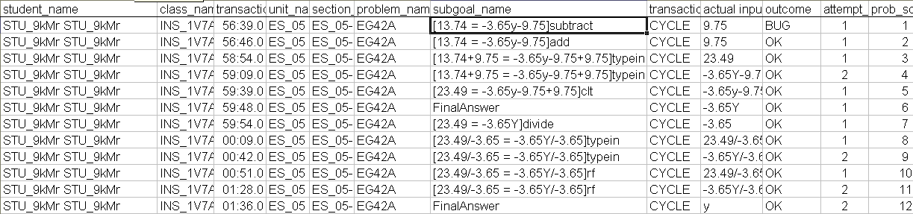
<Fixed version>
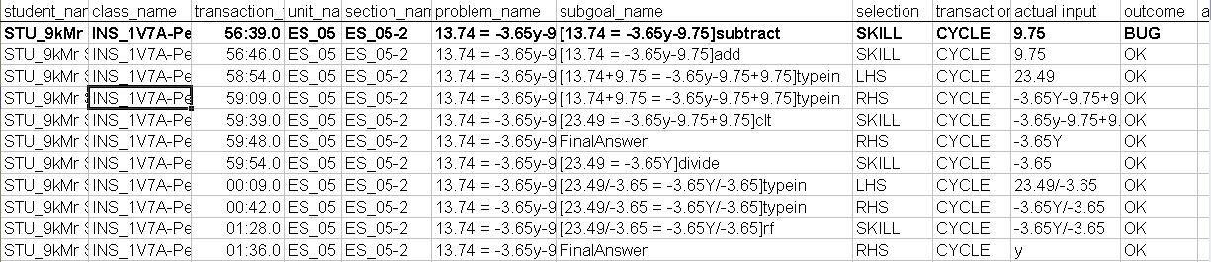

For skills that are not divide, add, subtract, and multiply, make sure you have modify the data to be order as skill, 2 typein’s. It is because in Carnegie Learning interface, some skills are applied separately to LHS and RHS. For the future development, it would be better to change the code to do following (example is clt skill):

  - separate clt skills for both sides: 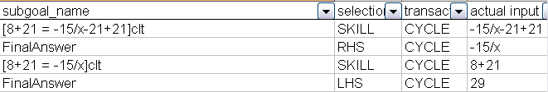
→

- If there is only one clt skill for one side and missing for the other side. Add another row for missing widget and set skill as auto-fill.
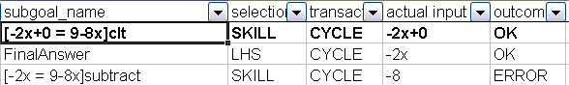
→

SimAlgebraDataConverter.java – This converts the Carnegie Learning raw data into CTAT tutor interface data. In order to run this program, the input data (raw data) should have a format of following:
(student name, problem name, skill, selection, actual input, subgoal name, and outcome).
Future work: do #3 of Raw Data Manipulation within this class, it would be better for a larger data set.

SimStudentBRDWriter.java –
1. This takes in the CTAT format of data (output of SimAlgebraDataConverter) and outputs BRD graphs of each problem.
2. This program is able to run with datashop 1.0. If the Carnegie Learning data is available in the database, running SQL and extracting data would be more efficient.
Future work:
1. Organize data by students. I was working on a small data set, so I did not need to, but when the data gets big, it would be better to organize by student and by problem.
2. Update the program to be compatible with datashop 2.0. Also make sure selection names are distinct for RHS and LHS, then there is no need to use raw data converter.

Build Script –
1. Converter – it is possible to just compile with javac. If you want to make a build script using ant, create a target name.
(e.g.) <target name="runConverter" depends="jar" description="run one unit test">
<java classname="edu.cmu.pslc.datashop.datalayer.SimAlgebraDataConverter" fork="true">
<classpath refid="test.classpath"/>
</java>
</target>

2. BRD Writer – If you want to compile it with javac, make sure to add the classpath of DorminWidgets.jar and xml-writer.jar packages. Also modify the code to not add datashop packages (for running SQL). In case of using a build script (in datashop):
(e.g.)
<target name="runWriter" depends="jar" description="run one unit test">
<java classname="edu.cmu.pslc.datashop.datalayer.SimStudentBRDWriter" fork="true">
<classpath path="${extlib.dir}/DorminWidgets.jar"/>
<classpath path="${extlib.dir}/xml-writer.jar"/>
<classpath refid="test.classpath"/>
</java>
</target>

Available Dataset Files:
- To load database with Carnegie Learning raw data (in wilkinsburg_partial.sql folder)
  - Open load.bat and change the name of database to the database name you assigned.
  - If database clean up is necessary, run empty_analysis_db2.0.bat. Also open and change the name of database.
- Past raw data set:
  - Adapted Unit 14 data for STU_ hrje.xls is the first dataset (smallest).
  - Unit 14 Problems_raw.xls is the larger dataset.
- Fixed data:
  - Sample_data.txt :small data set
  - Problems_6_5.txt & Problems_6_20.txt: larger data set.
- Output BRD files:
- Sim_output folder contains BRD files by its date.

Machine: Mead.cs.cmu.edu mysql root password: seventeen

